16-09-2015

Members

Frederik Andersen - 201270789  
Morten Morberg Madsen 201270993

Marlene Olsen – 201271078

Jacob Mose Hansen - 201270410

ITSMAP Theme project

Synopsis – Group 3

# Contents

2 Vision 1

3 Use Case 1

4 Description + Drawings 1

# Vision

## Vision on the app

The vision is to connect experienced students with less experienced students in order to help with particular problems. These problems can be homework, assignments and so on. This app has an intern mail system, which will help with communication between the students. The students can make a post of what kind of problems they need help solving, and a search function for older students to find specific posts. This app is specific made for elementary school to college level.

## Vision on our work

We hope to gain specific skills and tools, while working on this app. The methods and tools we want to achieve during this project will help us with future applications that we might work on. Teamwork will help us communicate between designer and developer. In the end, it would be awesome if our app would actually be published and successful to help students get the help they need.

# Use Case

Hereby a use case description of the app, the cases are pretty simple and easy to understand, therefore the Use Cases themselves should give an understanding of the possibilities in the app.

|  |  |
| --- | --- |
| USE CASE ID# | 1 |
| Name | Create new profile |
| Goal | The user should be able to create a new profile |
| Actors | User |
| Start condition | User should start up the app. |
| Description | 1. Press [Create new profile] 2. Insert “User name” “Full name”, “Sex”, “Location” “Password” & “Confirm Password” in associated text fields. 3. Press [Create]    1. (EXCEPTION) Handling of incorrect user inputs. 4. The user is proceeded to the “Start Screen” |

|  |  |
| --- | --- |
| USE CASE ID# | 2 |
| Name | Login |
| Goal | The user should be able to login with an existing profile |
| Actors | User |
| Start condition | User must have created a profile, and startup the app |
| Description | 1. User insert “User name” and “Password” in the associated text fields. 2. Press [Login]    1. (EXCEPTION) Handling of incorrect user inputs. 3. The user is proceeded to the “Start Screen” |

|  |  |
| --- | --- |
| USE CASE ID# | 3 |
| Name | Search posts |
| Goal | The user should be able to search through posts, by tag searching. |
| Actors | User |
| Start condition | User must be logged in and be in “Start Screen” |
| Description | 1. The user insert tags into the search field at the top of “Start Screen” 2. Press [Search] 3. The matching topics are posted in “Posts” |

|  |  |
| --- | --- |
| USE CASE ID# | 4 |
| Name | View newest posts |
| Goal | The user should be able to view the newest posts |
| Actors | User |
| Start condition | User must be logged in and be in “Start Screen” |
| Description | 1. Press [Posts] 2. “Posts” activity is shown. |

|  |  |
| --- | --- |
| USE CASE ID# | 5 |
| Name | Edit profile |
| Goal | The user should be able to adjust profile information |
| Actors | User |
| Start condition | User must be logged in and be in “Start Screen” |
| Description | 1. Press [Profile] 2. Choose the desired information, to be edited 3. Edit information 4. Press [Save] |

|  |  |
| --- | --- |
| USE CASE ID# | 6 |
| Name | Create new post |
| Goal | The user should be able to create a new post, for other users to view. |
| Actors | User |
| Start condition | User must be logged in and be in “Start Screen” |
| Description | 1. Press [New post] 2. Insert post name, tags and remaining post information for a new post. 3. The post is now created, and viewable in “Posts” |

|  |  |
| --- | --- |
| USE CASE ID# | 7 |
| Name | View messages |
| Goal | The user should be able to view personal messages between two users. |
| Actors | User |
| Start condition | User most be logged in and be in “Start Screen” |
| Description | 1. Press [Messages] 2. The newest messages are post to the user |

|  |  |
| --- | --- |
| USE CASE ID# | 8 |
| Name | Log out |
| Goal | The user should be able to logout |
| Actors | User |
| Start condition | User most be logged in and be in “Start Screen” |
| Description | 1. Press [Profile] 2. Press [Log out] 3. The user is moved to “Login screen” |

# Component model

These drawings are the first draft ideas of the apps looks. In the process of these drawings, the key goal was to make the design as user friendly as possible, this was succeeded by keeping “Keep It Simple Stupid” in mind.

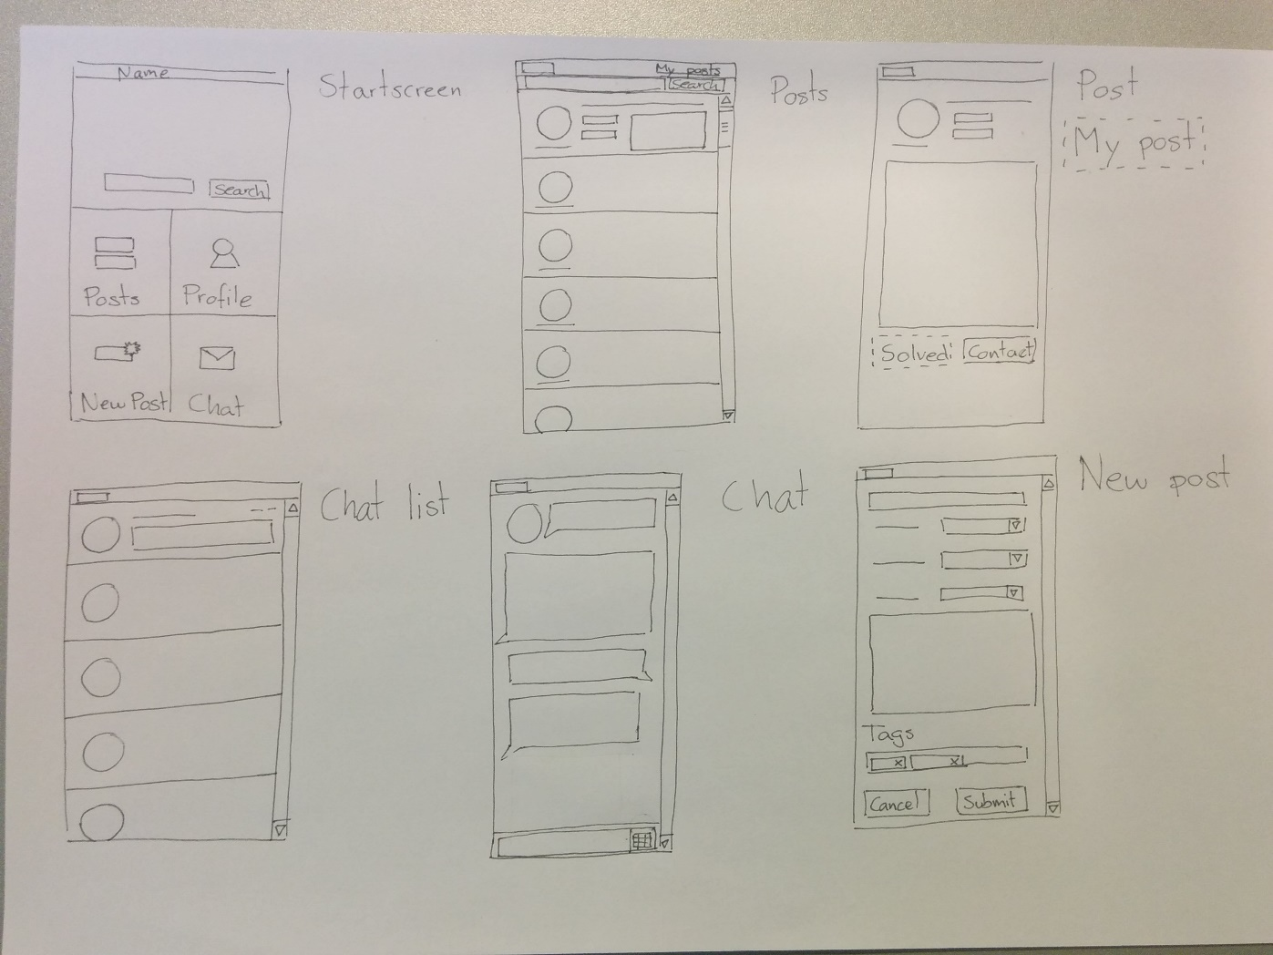

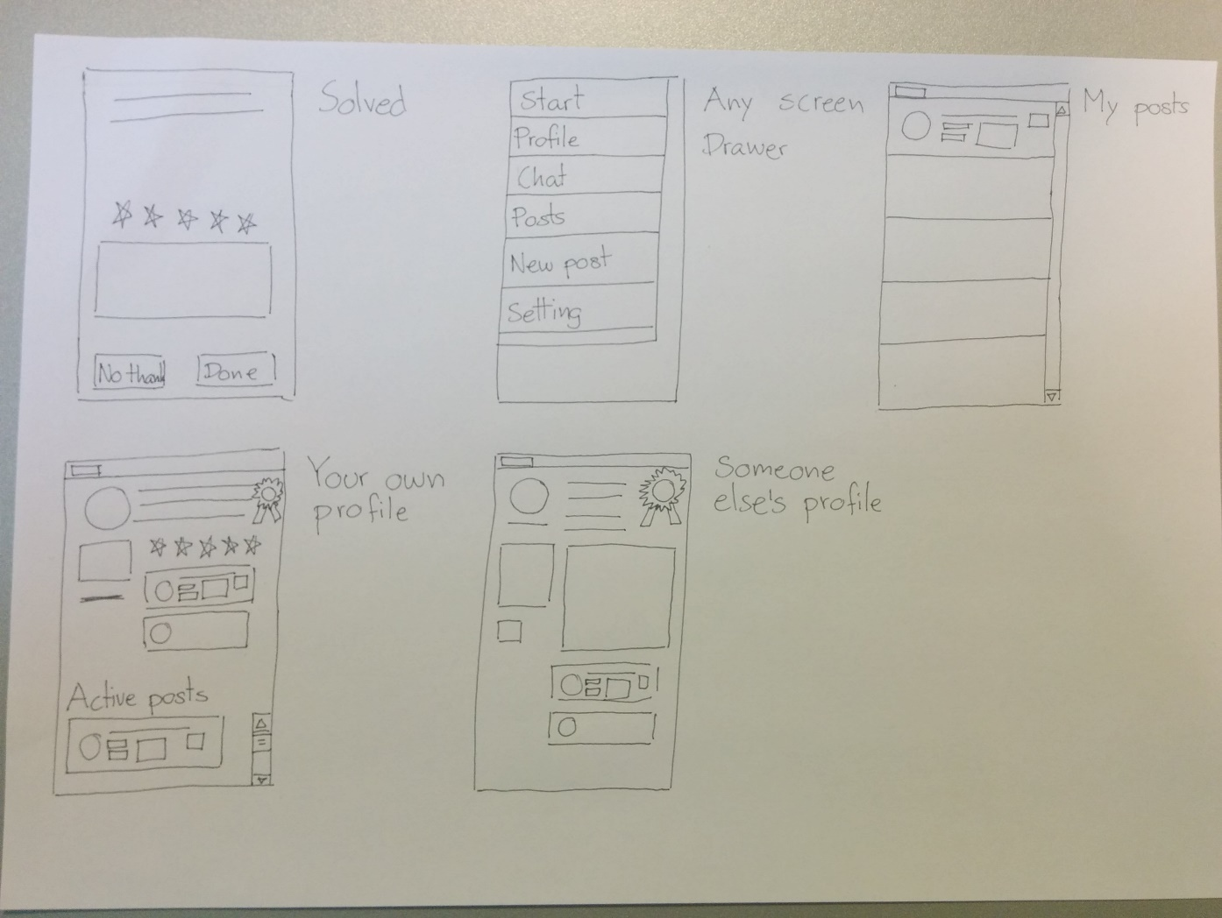

## Implementation thoughts

During the first design phase of the app, implementation suggestions also were discussed. We realize that we definitely will be including topics from the course such as:

* Intents and App Resources (general app functionalities)
* The Android UI (user interface handling)
* Service and UI (functionalities + user interface handling)
* Fragments (functionalities + user interface handling)
* Persistence: preferences and SQLite (Database handling for user + posts)
* *Maybe:* Localization and public service (Might be included, for better user experience)
* Networking + Connectivity to internet (For posts and user mail system.